Project Name |  | Confidentiality Level
DBMS Project |  | For Recipients’ Reference Only
Project ID | Version | Document Code
BP | 1.0 | Project ID_RA_001

DBMS Requirements Specification

15301002 程 辰
15301009 倪施杰



Copyright © Ruankosoft Technologies(Shenzhen), Co., Ltd.
. All Rights Reserved
Revision Record
Date | Revision Version | CR ID /Defect ID | Sec No. | Change Description | Author
Content
1 Introduction 7
1.1 Purpose 7
1.2 Scope 7
2 General description 7
2.1 Software perspective 7
2.1.1 About the Project 7
2.1.2 Environment of Product 7
2.2 Software function 7
2.3 Actors 8
2.4 User characteristics 8
2.5 Assumptions & Dependencies 9
3 Specific Requirements 9
3.1 System Use Case 9
3.2 Database Management 9
3.2.1 Functional Requirements1 10
3.2.2 Drop Database 10
3.3 Table Management 11
3.3.1 Create Table 11
3.3.2 Alter Table 12
3.3.3 Drop Table 12
3.4 Field Managent 13
3.4.1 Add Field 13
3.4.2 Alter Field 13
3.4.3 Drop Field 14
3.5 Data management 14
3.5.1 Insert Record 14
3.5.2 Update Record 15
3.5.3 Select Record 15
3.5.4 Delete Record 16
3.6 Index Management 16
3.7 Client Management 16
3.8 Transaction Management 16
3.9 Integrity Management 16
3.10 Database Maintenance 17
3.11 Security Management 17
3.12 Data Information 17
3.12.1 Data type 17
3.12.2 Integrity 17
3.12.2.1 Entity Integrity 17
3.12.2.2 Referential Integrity 17
3.12.2.3 User-defined Integrity 17
3.12.3 Database file 18
3.12.4 Database Description File 19
3.12.4.1 File Name 19
3.12.4.2 File Structure 19
3.12.4.3 Database information structure 19
3.12.5 Table Description File 19
3.12.5.1 File Name 19
3.12.5.2 File Structure 19
3.12.5.3 Table information structure 19
3.12.6 Table Definition File 20
3.12.6.1 File Name 20
3.12.6.2 File Structure 20
3.12.6.3 Field information structure 20
3.12.7 Record File 20
3.12.7.1 File Name 20
3.12.7.2 File Structure 21
3.12.7.3 Record information structure 21
3.12.8 Integrity Description File 21
3.12.8.1 File Name 21
3.12.8.2 File Structure 21
3.12.8.3 File information structure 21
3.12.9 Index Description File 21
3.12.9.1 File Name 21
3.12.9.2 File Structure 22
3.12.9.3 Index information structure 22
3.12.9.4 Index data file 22
4 Interface Requirements 22
4.1 User Interface 22
4.2 Software Interface 22
5 Overall Design Constraints 22
5.1 Hardware Limitations 22
5.2 Technology Limitations 23
6 Software Quality Attributes 23
6.1 Reliability 23
6.2 Usability 23
7 Requirements Classification 23

Keywords: software requirement specification DBMS users
Abstract:
List of abbreviations: Describe abbreviations in this document, full spelling of the abbreviation and Chinese explanation should be provided.
Abbreviations | Full spelling | Chinese explanation
DBMS | Database management system | 数据库管理系统

Introduction

Purpose
This manual describes requirements from users for functions of the DBMS. The reader includes users, project administrators, testers, designers, developers. The manual focuses on function requirements of DBMS, performance and interfaces of developed software.

Scope
This manual analyzes the logical model of DBMS from users’ perspective. It lists functions and services. The manual omits developments skills and describes user requirements.

General description

Software perspective

About the Project
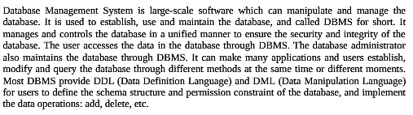.

Environment of Product
This is a windows desktop window program. It stores the data with the file system of the operating system. It can implement the communication between the client and server through the network.

Software function
The function structure diagram is follows:
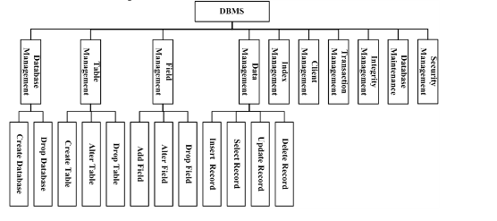
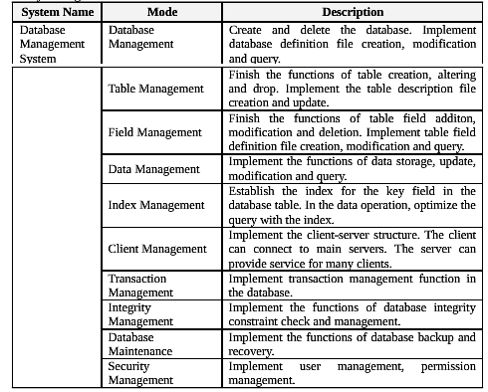

Actors
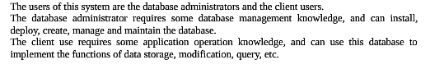.

User characteristics 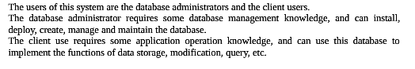

Assumptions & Dependencies

Specific Requirements

System Use Case
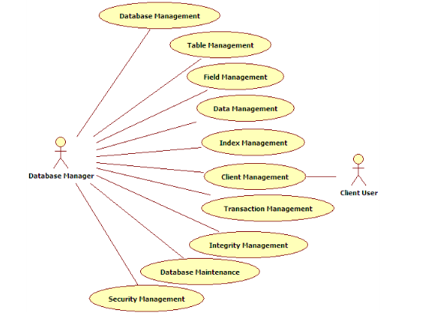

Database Management
1. Sub-module introduction
Create and delete the database. Implement database definition file creation, modification and query..

2. Sub-module use case diagram
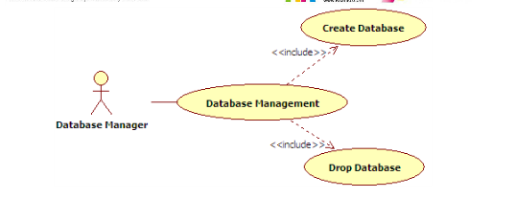.

Functional Requirements1
1. Introduction
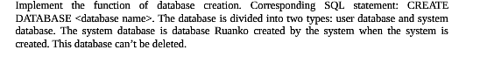
2. Inputs
3. Process
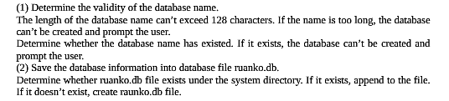
4. Output

Drop Database
1. Introduction
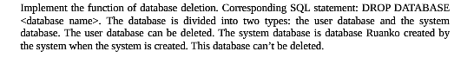
2. Inputs
3. Process
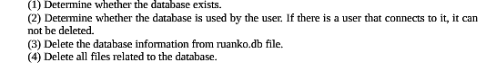
4. Output

Table Management

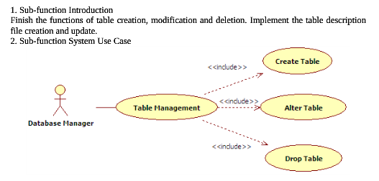

Create Table
1. Introduction
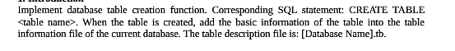
2. Inputs
3. Process
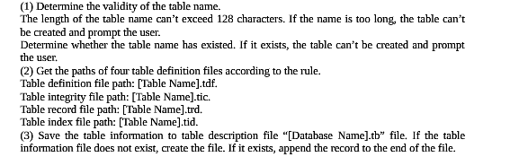
4. Output

Alter Table
1. Introduction
2. Inputs
3. Process
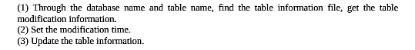
4. Output

Drop Table

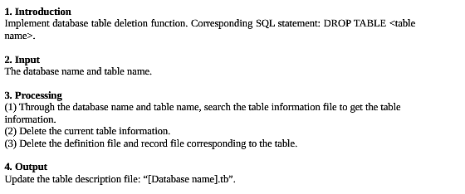

Field Managent
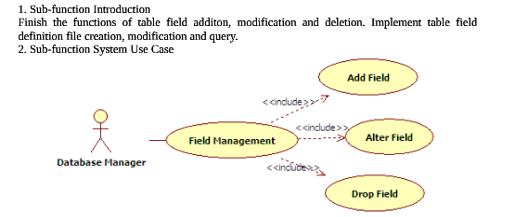

Add Field
1. Introduction
2. Inputs
3. Process
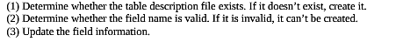
4. Output

Alter Field
1. Introduction
2. Inputs
3. Process
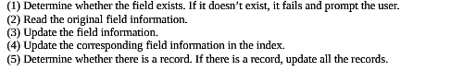
4. Output
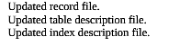

Drop Field
1. Introduction
2. Inputs
3. Process
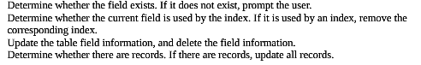
4. Output


Data management

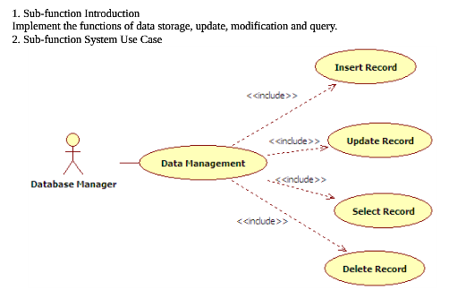

Insert Record
1. Introduction
2. Inputs
3. Process
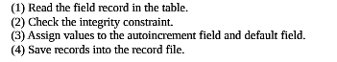
4. Output

Update Record
1. Introduction
2. Inputs
3. Process
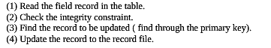
4. Output

Record file.

Select Record
1. Introduction
2. Inputs
Database name,table name
3. Process
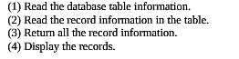
4. Output

Delete Record
1. Introduction
2. Inputs
3. Process
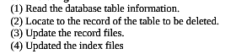
4. Output

Index Management

Client Management

Transaction Management

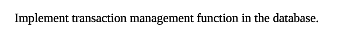

Integrity Management

Database Maintenance

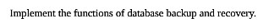

Security Management

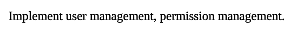

Data Information

Data type

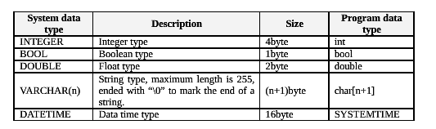

Integrity

Entity Integrity

PRIMARY KEY

Referential Integrity

FOREIGN KEY

User-defined Integrity

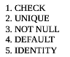

Database file

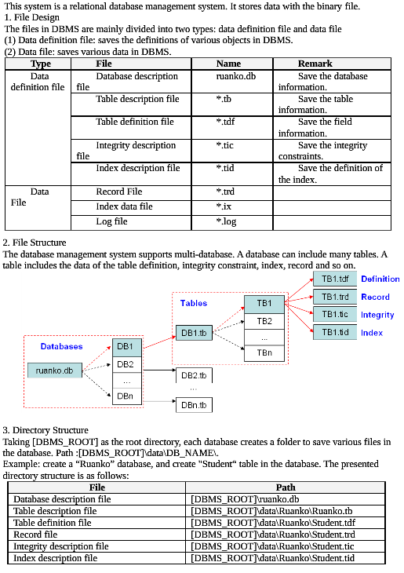

Database Description File

File Name

ruanku.db

File Structure

Database information structure

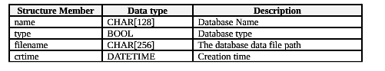

Table Description File

File Name

File Structure

Table information structure

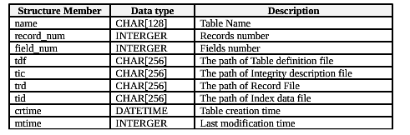

Table Definition File

File Name

File Structure

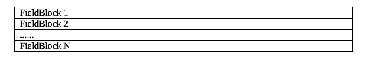

Field information structure

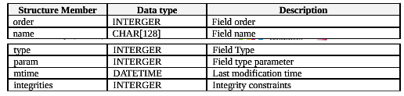

Record File

File Name

File Structure

Record information structure

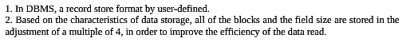

Integrity Description File

File Name

File Structure

File information structure

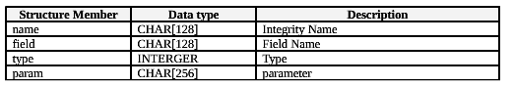

Index Description File

File Name

File Structure

Index information structure

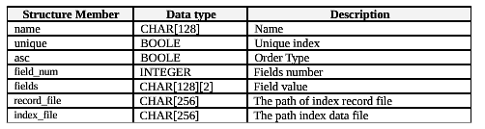

Index data file

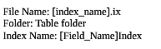

Interface Requirements

User Interface
The resolution is 1024*768 and software interfaces should adapt to the screen dimension.

Software Interface
This is a windows application program with GUI.

Overall Design Constraints

Hardware Limitations
Minimum configuration on a computer:
CPU: 1 GHZ
Memory: 128 MB

Technology Limitations
File format: binary mode file format
Coding standard: C++ Coding standard

Software Quality Attributes

Reliability
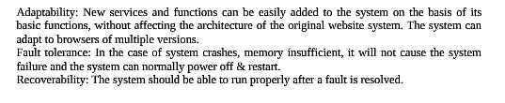

Usability
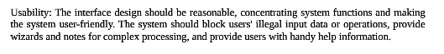

Requirements Classification
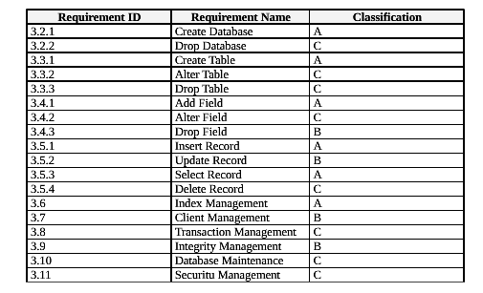
Importance of requirements is classified as following:
A. Mandatory: absolutely essential features, without which the product development will be canceled.
B. Important: unessential features that may affect the viability of the product.
C. Nice to have: desired features, the absence of which will not affect the product viability.

